**Failed Test Report**

1. **Description:**

The book details page does not present any book information when redirecting from books listing page.

**Priority:** **High**

This bug blocks the functionality of viewing individual book details feature.

1. **Steps to Reproduce**
2. Navigate to the book store page: <https://demoqa.com/books>
3. Click on any book link under the Title column in the table.

Eexample:Click on “Git Pocket Guide” (<https://demoqa.com/books?book=9781449325862>)

1. **Expected result**
2. User should be redirected from the book page to the book details page: <https://demoqa.com/books?book=9781449325862>
3. The book details page should display the correct book information.
4. **Actual result**
5. User is redirected to the book details page.
6. The book details page shows a blank page instead of showing the book content.
7. Other books have the same issue.

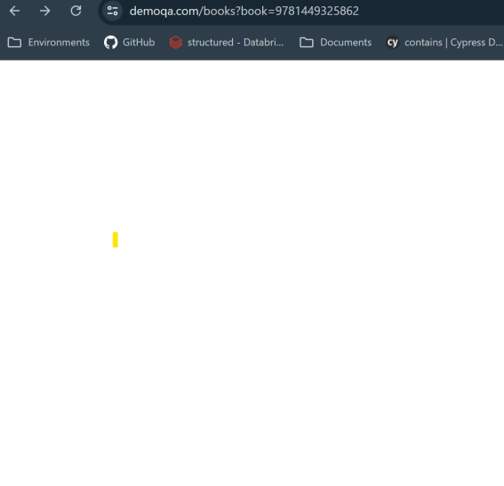

1. **Enviroment**

Test Environment: Production <https://demoqa.com/books>

Browsers:

* Chrome: Version 126.0.6478.182 (Official Build) (64-bit)
* Firefox: 134.0.2 (64-bit)

OS: Windows 11

1. **Investigation**
2. **Using chrome developer tools to check:**

the book details page response, the div element "app" is empty. This may the reason why the page is blank.

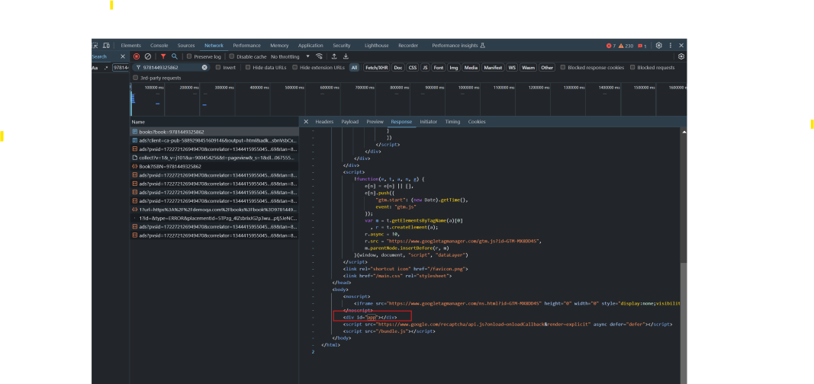

1. **Checked the book API: GET /BookStore/v1/Book** on Swagger to make sure the book existing:
2. Go to GET book api <https://demoqa.com/swagger/#/BookStore/BookStoreV1BookGet>
3. Enter the ISBN : 9781449325862 and click the Execute button to executed the request.

The API successfully returned valid book data for the given ISBN, confirming that the book exists.

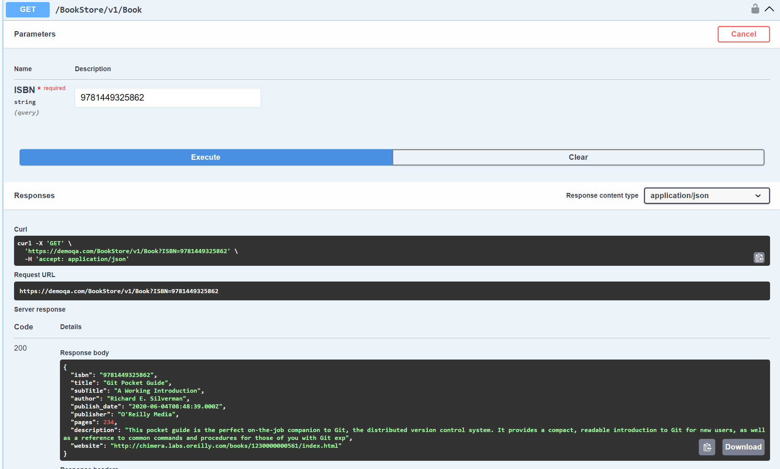

1. **Root Cause**

* The issue is either the book details page implementation appears to be incomplete.
* Or a bug in the page that’s preventing it from properly rendering the data received from the back-end.